Business Proposal: The "StageSync" Platform
In the current world, if a company wants to hire an anchor for a wedding, a corporate product launch, or a concert, they usually have to call friends or agents. It’s messy and slow.
Goal: To create a single digital "hub" where talent meets opportunity.

- Problem Statement
The event hosting industry currently lacks a unified digital marketplace for professional anchors. Talent discovery is inefficient, relying heavily on personal networks, which limits opportunities for skilled anchors and restricts choices for event organizers.
Core Pain Points:
- For Anchors: Lack of a professional portfolio space to showcase live event schedules and attract new leads.
- For Hosts/Companies: Difficulty in verifying anchor quality, checking availability, and finding niche talent within specific budgets.
- For Users: No single source of truth to discover events based on the specific "star power" or style of an anchor.

- How it Works (The Three Perspectives)
Who | Their Problem | The Solution (Your App)
The Anchors | They have talent but no place to show their schedule or get "discovered." | A Professional Portfolio where they list past work, fees, and upcoming shows.
The Hosts (Companies) | They struggle to find the "perfect fit" for their specific event budget and style. | A Search Engine to find anchors by language, style, or price, and a "Job Board" to post vacancies.
The Normal Users | They want to go to events but don't know where their favourite anchor is performing next. | An Event Discovery & Ticketing tool to see what's happening and buy a seat.

- Business Objective & Impact
The primary business goal is to standardize the talent acquisition process in the event industry.
Market Impact:
- Market Efficiency: Instead of 20 phone calls, a company can find an anchor in 3 clicks. This "saves time," and in business, time is money.
- Transparency: Implementing a structured review and rating system ensures quality control, which is currently missing in the unorganized sector.
- Monetization Potential (Future Goal): Beyond a simple directory, the platform can scale through commission-based ticket sales, premium listings for anchors, and featured event advertisements for companies.

- Features
 | Anchor | Hosts/Companies | Normal User
Primary Features | - Digital Portfolio  - Availability Calendar  - Find Events  - Event Application | - “Anchor Wanted” (List their Need)  - Find Anchor (search and filter)  - Publish event for public (users) | - Event Feed  - Ticket Booking  - Follow Anchor
Secondary Features | - Display star rating and testimonials from previous company/host  - Receive payment from host | - Compare 2-3 anchors side by side to find best  - Direct Chat/Message Anchors  - Pay Anchor | - Social Sharing  - Event Remainder

- The Star Schema Skeleton
1. Central Fact Table: Fact_Assignments
This is your Bridge/Applications table. It sits in the centre and records every "interaction" between a host, an anchor, and an event.
- Unique ID (Primary Key)
- Event_ID (Link to Events)
- Anchor_ID (Link to Anchor Profiles)
- Host_ID (Link to Users)
- Application_Status (Pending, Accepted, Rejected)
- Timestamp (When did this happen?)
2. Dimension Table: Dim_Users
This is your core User Table. It holds the "identity" of everyone on the platform.
- User_ID (Unique ID)
- Name & Email
- Password Hash
- Role_Type (Anchor, Host, or Normal User)
- Account_Created_Date
3. Dimension Table: Dim_Anchor_Profiles
This is your Profiles Table. It contains deep details specifically for the anchors.
- Profile_ID (Unique ID)
- User_ID (Link back to the User table)
- Specialization (e.g., Corporate, Wedding, Comedy)
- Past Work Links
- Base_Fee
- Languages_Spoken
- Average_Rating (Calculated field)

4. Dimension Table: Dim_Events
This holds the details for the Events.
- Event_ID (Unique ID)
- Host_ID (The User who created it)
- Event_Title
- Description
- Event_Date & Time
- Location/City
- Status (Open for Applications, Anchor Hired, Completed)
5. Dimension Table: Dim_Tickets
To satisfy the Normal User perspective, you eventually need a way to track who is attending which event.
- Ticket_ID
- Event_ID (Which show?)
- User_ID (Who bought it?)
- Booking_Date
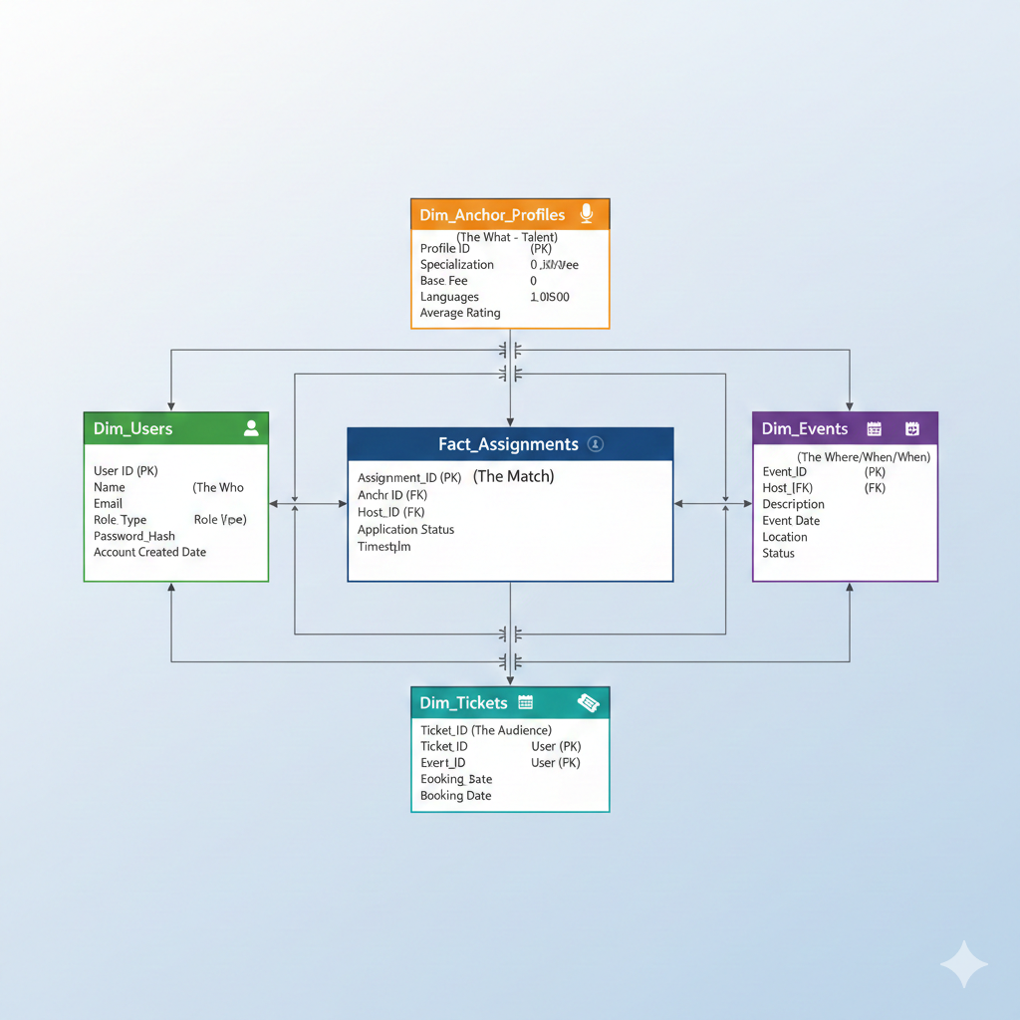
- Endpoints

1. Authentication
Method | Endpoint | Description | Input
POST | /register | Registers a new Host, Anchor, or User. | { "Name": "...", "Email": "...", "Password": "...", "Role_Type": "Host" }
POST | /login | Authenticates a user and returns their ID/Role. | { "Email": "...", "Password": "..." }

2. Host Operations
Method | Endpoint | Description | Input / Params
POST | /host/{user_id}/create-event | Creates a new event. | { "Event_Title": "...", "Description": "...", "Event_Date": "...", "Location": "..." }
GET | /host/{host_id}/dashboard | Shows all created events and the list of applicants for each. | Param: host_id
PUT | /host/{host_id}/hire/{application_id} | Hires an anchor, confirms the event, and rejects other applicants. | Params: host_id, application_id

3. Anchor Operations
Method | Endpoint | Description | Input / Params
PUT | /anchor/{user_id}/update-profile | Updates professional details (Fee, Experience, etc.). | Body: { "Specialization": "...", "Base_Fee": 5000, ... }
GET | /anchor/{user_id}/dashboard | Shows profile summary and status of all applications. | Param: user_id
POST | /anchor/{user_id}/apply/{event_id} | Submits an application for an "Open" event. | Params: user_id, event_id

4. User (Audience) Operations
Method | Endpoint | Description | Input / Params
POST | /user/{user_id}/book/{event_id} | Books a ticket for a "Confirmed" event. | Params: user_id, event_id

5. Common / Discovery
Method | Endpoint | Description | Input / Params
GET | /events/feed/{user_id} | Smart Feed:  • Anchors see "Open" events (Jobs).  • Users see "Confirmed" events.  • Hosts see their own events. | Params: user_id

